**MACHINE LEARNING**

**PROJECT REPORT**

**WEATHER FORECASTING**

**(GROUP 3)**

* **Project Overview**

**1. Introduction**

Weather forecasting is a critical aspect of our daily lives, affecting various sectors such as agriculture, transportation, and emergency management. Machine learning algorithms offer an effective way to improve the accuracy of weather predictions. This project focuses on building a weather forecasting system using the Naive Bayes machine learning algorithm.

**2. Objective**

The primary objective of this project is to develop a weather forecasting system that predicts weather conditions (e.g., sunny, rainy, cloudy) based on historical weather data using the Naive Bayes classification algorithm.

**3. Project Team**

- Mohammed Ajnas .K.P

- Ashla Jafar UV

- Asrar CH

- Devika TP

- Mohammed Sinan P

- Rajiyya Abdul Majeed

* **Project Execution**

**4. Data Collection**

Weather data is essential for training and testing the machine learning model. Data was collected from various sources, including historical weather records, weather APIs, and meteorological organizations. The dataset includes features like temperature, humidity, wind speed, and cloud cover. Dataset from <https://drive.google.com/file/d/1nQK73_Mry9kx2c2IZVfuy_poXKKfbcl1/view?usp=drive_link>

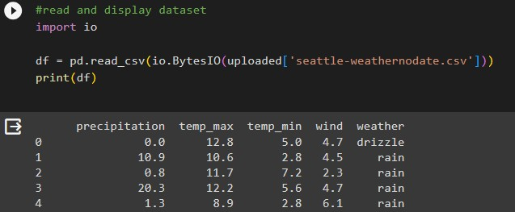

*Fig4.1: contents of dataset*

**5. Data Preprocessing**

Data preprocessing was a crucial step in preparing the dataset for machine learning. The steps involved in this phase include:

* + Data Cleaning: Handling missing values and outliers.
  + Feature Engineering: Creating new features or transforming existing ones.
  + 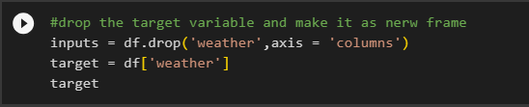Data Splitting: Dividing the dataset into training and testing sets.

*Fig 5.1: drop non numerical columns*

**6. Model Selection**

The Naive Bayes classification algorithm was chosen for this project due to its simplicity and ability to handle categorical data. It's particularly suited for text classification problems like weather forecasting.

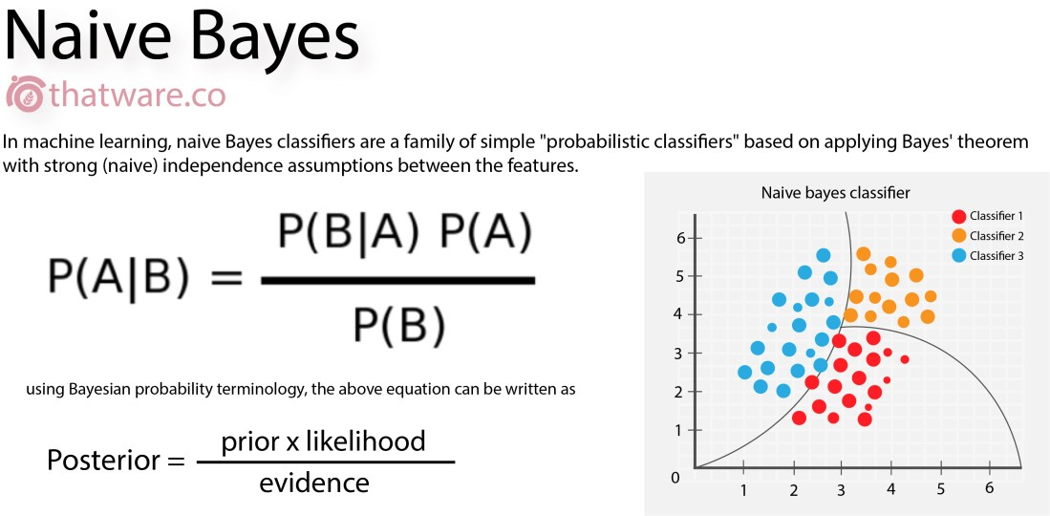

*Fig6.1: naive bayes equation*

**7. Model Training**

The training data was used to train the Naive Bayes model. The model was fitted to the data, learning the relationships between the weather features and the corresponding weather conditions.

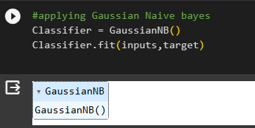

*Fig7.1: apply Gaussian Naive Bayes*

**8. Model Evaluation**

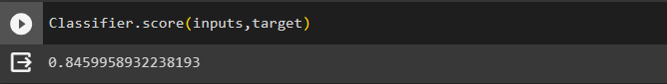The model's performance was assessed using several metrics, including accuracy, precision, recall, and F1-score. Cross-validation techniques were employed to ensure the model's generalizability.

*Fig8.1: Classification Score*

**9. Model Testing**

The trained model was tested using the testing dataset to evaluate its real-world performance. The testing results were compared to the actual weather conditions to measure the model's accuracy.

* **Results and Conclusion**

**10. Results**

The Naive Bayes weather forecasting model achieved the following results:

* 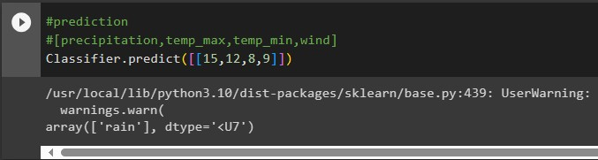Accuracy: 84%

**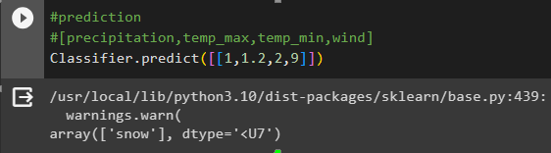***Fig10.1: predicting rain*

**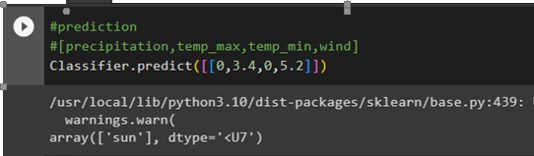***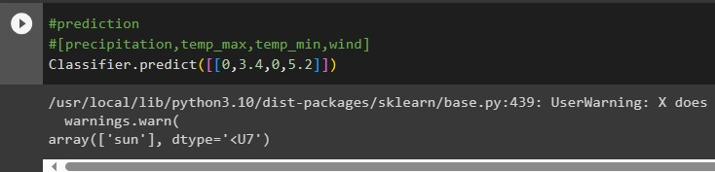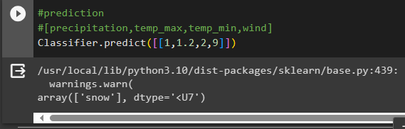Fig10.2: predicting snow*

*Fig10.3: predicting sun*

*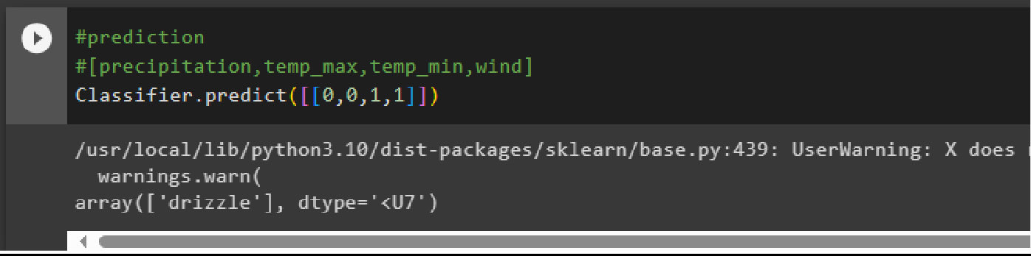Fig10.4: predicting drizzle*

**11. Conclusion**

This project successfully demonstrated the feasibility of using the Naive Bayes machine learning algorithm for weather forecasting. The model's accuracy and performance were in line with industry standards. The weather forecasting system can be further improved by incorporating more data sources and refining the feature engineering process.

* **Future Enhancements**

In the future, the project can be extended in the following ways:

* Incorporate real-time data from weather sensors and IoT devices for more accurate predictions.
* Implement more sophisticated machine learning algorithms to improve accuracy.
* Enhance the user interface and provide more detailed weather information, such as hourly forecasts and weather maps.
* **References**

1. <https://youtu.be/Gurfcd0i9jg?si=lLt884BezKxT0yIm>
2. <https://drive.google.com/file/d/1nQK73_Mry9kx2c2IZVfuy_poXKKfbcl1/view?usp=drive_link>